**GS-713 TAW BY SOIL DEPTH PLAN TEST PLAN**



April 9, 2015

**Table of Contents**

1. Purpose and Scope 3

1.1 Limitations 3

1.2 Sprint/Release Schedule 3

1.3 Assumptions and Risks 4

2. Test Strategy 4

2.1 Test Flow 4

3. Test Environment 5

3.1 Supported Devices and Browsers 5

4. Test Case: Verify Total Available Water (TAW) by Soil Depth; Confirm Design and Defaults (GS-713). 6

4.1 Test Case: Verify the In-Season Plan is designed as expected when the Soil Depth chart is the focused. 7

4.1.1 Test Case: Verify the Soil Depth Chart is designed and defaults as expected. 11

4.1.2 Test Case: Verify the Daily and Pivot Pass Metrics Selection is designed and defaults as expected; examine Selection Highlighting. 15

4.1.3 Test Case: Verify the Precipitation Forecast components design and defaults as expected. 18

5. Test Case: Verify the In-Season Plan functionality is as expected (Edit Mode). 23

5.1 Test Case: Verify the editing the In-Season Plan functionality is working as expected. 24

5.1.1 Test Case: Verify the editing the In-Season Plan with Apply Cycle/Rate Toggle and Comparison functionality is working as expected. 29

# Purpose and Scope

This test plan describes the strategy for exercising the functionality **and/or fixes** for the JIRA issues in this release*.* As features are being designed the test scenarios described in this document will be updated to accommodate the modifications to the plans.

The purpose and scope of this test plan is to list and describe the test strategy for the following Jira Issues:

|  |  |  |
| --- | --- | --- |
| **Issue** | **User Story** | **Sprint/Release Schedule** |
| **GS-713**  **Sub task** | Total Available Water (TAW) by Soil Depth. | Sprint 10 |
| GS-889 | Total Available Water (TAW) by Soil Depth. | Sprint 11 |

* The focus of this test is from the front end. It is only to examine and access the quality of the general functionality and that the current Fertility functionality has not degraded due to this change.

## Limitations

This test is limited as follows:

To front end testing. There is no back end testing.

Only the features mentioned in the box above is tested, with light testing of the areas of this feature It does not include a full regression test.

## Sprint/Release Schedule

Refer to the grid above for sprint schedule information.

## Assumptions and Risks

* Manual tests will be designed to allow any person to execute the test scripts. They will also be designed with the assumption for easy conversion to automated scripts in the future.
* Test Plan for this effort will be available as an attachment against the **Test plan** JIRA issue in pdf format.
* Functionality will be delivered by Engineering on time.
* Required resources will be available i.e. Test environments, Devices i.e. Laptop/iPad etc.
* There are no specification documents. Requirements are given via sprint discussions, email and/or accepted design Wire Frames therefore, test plans are built against these matters.
* Handling Leap year dates: there is no testing in this area; it is assume the code used in JavaScript Date object will know how to determine this situation and present the expect dates. This applies to date control, Date input, Dates in Settings, etc.

# Test Strategy

The following test strategies will be considered:

**Content** – is the message being communicated by the page delivered to the user?

**Functionality** – can users do everything they need to?

**Display** – does the page look as it should do in terms of style and layout?

A check that the content, functionality and display all work as intended. Verification of the different types of interaction will be exercised if applicable, for example: Navigation, Form filling – are the input boxes behaving as expected?

## Test Flow

The test scenarios designed in this document will flow as described below in each Test Case section:

* User Logs on.
* Selects an Operation or a Farm depending upon access.
* Proceeds to examine the feature under test
  + Confirm the display, design, defaults and expected functionality
  + Some regression will be done on the existing functionality as the Tester examine the surrounding areas of the feature under test.

# Test Environment

Unless otherwise instructed, testing will be executed against the following environment/ configurations:

**Test Environment**: <https://gmctest.east.pioneer.com/>

## Supported Devices and Browsers

**Device:** Laptop

**O/S:** Win 8.1

**Screen Resolution:** 1366 X 768

**Browsers:**

~~IE 9 (IE10 will also be examined)~~

IE 10 and current IE version

Firefox latest version (currently Version 36x)

Chrome latest version (currently Version 41.0.2272.118 m)

**Device:** IPad

**O/S:** Latest Version TBD at time of test and will be noted in JIRA

**Screen Resolution:** 768 X 1024

**Browser:**

Safari/Latest version

# Test Case: Verify Total Available Water (TAW) by Soil Depth; Confirm Design and Defaults (GS-713).

The test scenarios presented in this test case will exercise the JIRA issue GS-713 with accompany sub tasks. **(See** Purpose and Scope**,** Limitations, Risks and Assumption section above).

|  |  |
| --- | --- |
| In-Season Available Water by Soil Depth, Depth Range Selected |  |

**Details shown here may be out dated. It is only an example.**

**Please check JIRA for the most recent information for this issue.**

## Test Case: Verify the In-Season Plan is designed as expected when the Soil Depth chart is the focused.

Scenarios will examine and focus on the In-Season Plan design and default settings.

| **Step** | **Perform Action** | **Expected Results** | **P**  **F**  **B** | **Remarks:** Use this section to add comments or notes. Or, actual results if feature was not as expected. You may also reference JIRA bug issue if a defect was written.  **PFB** = (P) assed, (F) ailed or (B) ypassed. The step was bypassed. |
| --- | --- | --- | --- | --- |
|  | **Instructions:**   * See the **Test Environment Supported Devices and Brower** section of this test plan for details. * Enter Browser/Device: | Able to follow instructions. | n/a |  |
|  | **Pre-requisites:**  **Clear** the cache of the browser under test before execution.  **To execute the scenarios** in this test case access to an Operation/Farm must contain at least 1 farm setup with the Water Irrigation Feature.  The following field configuration must also available.   * Fields that have been set up with a probe in the ground. | Test pre-requisites are met.  Familiar with the JIRA story. |  |  |
|  | * Open Jira to GS-713   [https://jira.appliedinvention.com/browse/GS-713](https://jira.appliedinvention.com/browse/GS-709)  Review the specification stated in this:  [Google Doc Water Balance Requirements](https://docs.google.com/a/dannenfeldt.com/document/d/1QPfHrAmKb_Kp-8M99dHP9vtcNt9UTbxbRU6xJA2cLHg/edit) | Able to do as instructed. |  |  |
|  | ***Note to Tester:*** Refer to the Wire Frames.  Observe and confirm any differences with JIRA/Owner expectations. | The latest wireframes will be referenced as instructed.  Able to continue testing. |  |  |
|  | **Test Set up:**  Log in as the User with an Operation as detailed in the Pre-requisites step. | **Able to follow instructions**: The User has at least 1 Farm 1 field setup for Water.   * Successfully logged in * Landed on the expected page. |  |  |
|  | **From** the Water page. Select a field for testing | * Able to do as instructed. * Selected a Field that has been setup that has a probe in the ground i.e. probe data coming in. |  |  |
|  | **Now click** or Tap on the Field’s Plan button . | * The **In-Season** **Plan Page** opens *defaulting* to Water Balance screen. * By default the “*bar chart”* is displayed representing the setup for the water balance. |  |  |
|  | Confirm the Page header (Title Area) is correct. | * There is a (**Back)** Arrow * The **Title** of the page is shown in the header and appears as expected. * The name of **Farm and Field** (Crop zone) is available and formatted correctly (consult wireframe.) * The **Crop zone Icon** is present and is as expected: represents the “shape” of the actual crop zone and its Icon coloring is correct for the stage it is in. * There is an **Edit Setup** button on the right side of page. |  |  |
|  | Confirm to the Right of the Plan View there is an Icon representing the **Soil Depth**. | * The **Soil Depth Icon** is available and positioned as expected. * The Icon resembles “*Roots”* and is legible on the device/browser under test. * It does not have the focused (since it is not the active the currently active display).   ***Note to Tester:*** Refer to the Supported Devices and Browsers section |  |  |
|  | * **Click or Tap**  on the “Roots” icon. | * Clicking on the Soil Depth icon displays the Total Water (TW) chart. * The “Roots” Icon is now highlighted. * The “Bar Chart” Icon becomes un-high-lighted. |  |  |
|  | Examine and confirm the Soil Depth Panel is as expected on default. | * The Panel’s Label is available and is positioned correctly. * The label displays the Min and Max Sensor ranges in its text. The text is as expected. * There is a Chart representing the field’s TW Depth variables. |  |  |
|  | Confirm the **Page footer** is available and designed as expected. | The page footer is as expected:   * There is text available detailing the current timeline (consult the current wireframe.) |  |  |
|  | Go on to the section to continue. | Able to do as instructed. |  |  |
| ***Testing is completed for this section***  **Record** Time it took to execute this test:____________________________  (This includes time it took for test setup. It does not include down time i.e. pauses in execution related to taking a break, attend a meeting, etc.) | | | | |

### Test Case: Verify the Soil Depth Chart is designed and defaults as expected.

Scenarios will examine and focus on the Water Balance Chart design and default settings.

| **Step** | **Perform Action** | **Expected Results** | **P**  **F**  **B** | **Remarks:** Use this section to add comments or notes. Or, actual results if feature was not as expected. You may also reference JIRA bug issue if a defect was written.  **PFB** = (P) assed, (F) ailed or (B) ypassed. The step was bypassed. |
| --- | --- | --- | --- | --- |
|  | **Instructions:**   * See the **Test Environment Supported Devices and Brower** section of this test plan for details. * Enter Browser/Device: | Able to follow instructions. | n/a |  |
|  | **Pre-requisites:**   * The Tester is continuing from the previous Test section. | Test pre-requisites are met. |  |  |
|  | * Open Jira to GS-713   [https://jira.appliedinvention.com/browse/GS-713](https://jira.appliedinvention.com/browse/GS-709)  Review the specification stated in this:  [Google Doc Water Balance Requirements](https://docs.google.com/a/dannenfeldt.com/document/d/1QPfHrAmKb_Kp-8M99dHP9vtcNt9UTbxbRU6xJA2cLHg/edit) | Able to do as instructed.  Familiar with the JIRA story. |  |  |
|  | ***Note to Tester:*** Refer to the Wire Frames.  Observe and confirm any differences with JIRA/Owner expectations. | The latest wireframes will be referenced as instructed.  Able to continue testing. |  |  |
|  | With the Soil Depth Panel opened.  **Verify** the TAW Chart design and defaults. | * There is selection menu shown next to the label text displaying the Sensor Range Min/Max values listed in the listbox controls. * The default selection is the shallowest sensor range and the sensor range at the full root depth for the date selected by the time slider. |  |  |
|  | Confirm the **Y-axis** default view :   * Verify the Y-axis is as expected | * The Y—axis displays a label “Available Water”. * There is an Icon resembling an encircled question mark beneath the label. * The Y-axis is composed of 1 inch markers going up to 5 inches starting with 0 as the first marker. |  |  |
|  | **Click or Tap** on the encircled **“?”.** | * A dialog opens displaying the Chart Legend. * It is design as expected. |  |  |
|  | **Click or Tap** on the Chart legend close button. | * Clicking on the encircled “X” button closed the dialog. |  |  |
|  | Confirm the **X-axis** default view :   * Verify the chart displays the Daily Metrics are as per requirements. | * The **X—axis** displays Markers beneath the bars.   - The Current Day Marker is the default.   * The Text “TODAY” appears next to the current day. * The additional Markers displays dates that are7 days prior to the Current day. * And, 10 days past the Current day. |  |  |
|  | * Verify the Markers display the **month** of the first day in the daily metric. | * The month of the first date is displayed and is abbreviated under the first bar in the metrics. |  |  |
|  | * Verify the Marker displays the **date** of the month. | * The date of the month is shown for each day in the bar metric. * The current date is highlighted. |  |  |
|  | * Verify the **Time Slider** is available and defaults to the current day and appears as expected. | * Pivot Pass time line is available and positioned on the screen as expected. * It defaults to the current day. * The selected timeline is darken and its line appears thicken to convey it is the selected time line. * It is not editable. |  |  |
|  | * Verify the Probe data Update Icon is available | * There is an Update Icon appearing beneath the encircled question. |  |  |
|  | * **Click or Tap on** the Icon | * The Icon spins while the update is in process**.** * A message is displayed to effect of “Updating. Please Wait…” (**GS-885)** * When this process is over the message disappears. |  |  |
|  | * Verify the Probe data Update   ***Note to Tester:*** *See Test limitation section for* **Confirming Probe Updates.** | * There is an Update Icon appearing beneath the encircled question. * Triggering an update causes the Icon to spin while the update is in process ( See **GS-885)** |  |  |
|  | **ad – hoc** **test:**   * Test the surrounding areas of this function | Able to do as instructed. |  |  |
| ***Testing is completed for this section***  **Record** Time it took to execute this test:____________________________  (This includes time it took for test setup. It does not include down time i.e. pauses in execution related to taking a break, attend a meeting, etc.) | | | | |

### Test Case: Verify the Daily and Pivot Pass Metrics Selection is designed and defaults as expected; examine Selection Highlighting.

Scenarios will examine and focus on the Daily /Pivot Metrics design expectations and default settings. And, review the Highlighting feature.

| **Step** | **Perform Action** | **Expected Results** | **P**  **F**  **B** | **Remarks:** Use this section to add comments or notes. Or, actual results if feature was not as expected. You may also reference JIRA bug issue if a defect was written.  **PFB** = (P) assed, (F) ailed or (B) ypassed. The step was bypassed. |
| --- | --- | --- | --- | --- |
|  | **Instructions:**   * See the **Test Environment Supported Devices and Brower** section of this test plan for details. * Enter Browser/Device: | Able to follow instructions. | n/a |  |
|  | **Pre-requisites:**  **Clear** the cache of the browser under test before execution.  **To execute the scenarios** in this test case access to an Operation/Farm must contain at least 1 farm setup with the Water Irrigation Feature.  The following field configuration must also available.   * Fields that have been set up with a probe in the ground. | Test pre-requisites are met.  Familiar with the JIRA story. |  |  |
|  | * Open Jira to GS-713   [https://jira.appliedinvention.com/browse/GS-713](https://jira.appliedinvention.com/browse/GS-709)  Review the specification stated in this:  [Google Doc Water Balance Requirements](https://docs.google.com/a/dannenfeldt.com/document/d/1QPfHrAmKb_Kp-8M99dHP9vtcNt9UTbxbRU6xJA2cLHg/edit) | Able to do as instructed. |  |  |
|  | ***Note to Tester:*** Refer to the Wire Frames.  Observe and confirm any differences with JIRA/Owner expectations. | The latest wireframes will be referenced as instructed.  Able to continue testing. |  |  |
|  | **After** Successfully logging in.  **From** the Water page. Select a field for testing | * Able to do as instructed. * Selected a Field that has been setup that has a probe in the ground i.e. probe data coming in. |  |  |
|  | **Now click** or Tap on the Field’s Plan button . | * The **In-Season** **Plan Page** opens. * The Water Balance Chart is displayed. |  |  |
|  | **Confirm that** the user can view a day’s metrics as follows:   * by clicking within the rectangular chart box * by clicking below it on the pivot pass line   **Perform** these actions to verify the expected results noted in the “Expected Results” box to the right. | * The Users can view a given daily metric as expected. * The selected date bar darkens. * A bubble-shaped dialog appears. |  |  |
|  | Verify the **Daily Water Balance Overlay** displays the TW, ET, and Active Roots. | * The dialog displays the TW, ET, and Active Roots. |  |  |
|  | **Click or Tap on**  any date in the X-axis | * The dialog displays the TW, ET, and Active Roots for **that** day. |  |  |
|  | **ad – hoc** **test:**   * Test the surrounding areas of this function: * **Selection Highlighting** refer to the wireframe for scenarios. | Able to do as instructed. |  |  |
| ***Testing is completed for this section***  **Record** Time it took to execute this test:____________________________  (This includes time it took for test setup. It does not include down time i.e. pauses in execution related to taking a break, attend a meeting, etc.) | | | | |

### Test Case: Verify the Precipitation Forecast components design and defaults as expected.

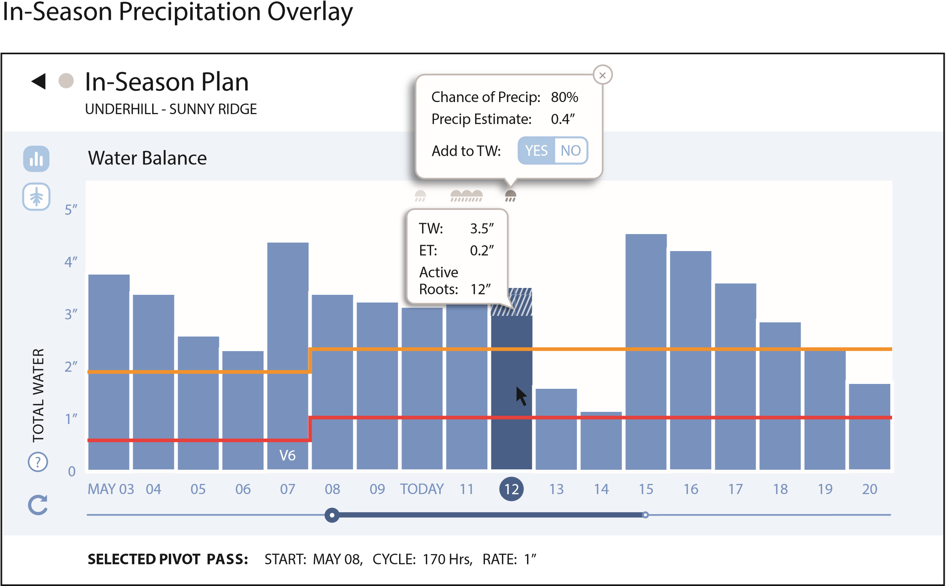Scenarios will examine and focus on the design expectations and default settings for precipitation forecasting.

| **Step** | **Perform Action** | **Expected Results** | **P**  **F**  **B** | **Remarks:** Use this section to add comments or notes. Or, actual results if feature was not as expected. You may also reference JIRA bug issue if a defect was written.  **PFB** = (P) assed, (F) ailed or (B) ypassed. The step was bypassed. |
| --- | --- | --- | --- | --- |
|  | **Instructions:**   * See the **Test Environment Supported Devices and Brower** section of this test plan for details. * Enter Browser/Device: | Able to follow instructions. | n/a |  |
|  | **Pre-requisites:**  **Clear** the cache of the browser under test before execution.  **To execute the scenarios** in this test case access to an Operation/Farm must contain at least 1 farm setup with the Water Irrigation Feature.  The following field configuration must also available.   * Fields that have been set up with a probe in the ground. | Test pre-requisites are met.  Familiar with the JIRA story. |  |  |
|  | * Open Jira to GS-713   [https://jira.appliedinvention.com/browse/GS-713](https://jira.appliedinvention.com/browse/GS-709)  Review the specification stated in this:  [Google Doc Water Balance Requirements](https://docs.google.com/a/dannenfeldt.com/document/d/1QPfHrAmKb_Kp-8M99dHP9vtcNt9UTbxbRU6xJA2cLHg/edit) | Able to do as instructed. |  |  |
|  | ***Note to Tester:*** Refer to the Wire Frames.  Observe and confirm any differences with JIRA/Owner expectations. | The latest wireframes will be referenced as instructed.  Able to continue testing. |  |  |
|  | **After** Successfully logging in.  **From** the Water page. Select a field for testing | * Able to do as instructed. * Selected a Field that has been setup that has a probe in the ground i.e. probe data coming in. |  |  |
|  | **Now click** or Tap on the Field’s Plan button . | * The **In-Season** **Plan Page** opens. * The Water Balance Chart is displayed. |  |  |
|  | Precipitation during a single day is indicated by the presence of three cloud icons in the area above the bar.  Confirm they are defaulting and designed as expected. | * The Y-axis component **do not** obscure the Cloud Icons. * The volume of rain forecast is portrayed by the darkness value of the cloud icon. * The amount of rain is conveyed by the number of cloud icons (one, two or three). |  |  |
|  | **Click or Tap**  on the cloud icons | * Clicking on each cloud icon displays a small popup with number values for percentage and amount of rain expected. |  |  |
|  | **Confirm** there is a toggle for adding to the Total Water.  ***Note to Tester:***  *For the following steps* Consult **GS-883** for specs. | * To **the right of the chart** is a toggle for setting the value to add to the total water. * It is easily identifiable by the user without having to guess what it is far. * It has 2 settings exclude or include precipitation.  **See GS-883** * The default value is set to exclude. |  |  |
|  | **Set the TW toggle** to Include (On) | * Able to do as instructed. |  |  |
|  | **With** the Precipitation Overlay opened: | * The **y-axis height** of the event’s bar will increase so the estimated amount is added. * The **bar area** that represents precipitation increase having a pattern of diagonal striping. * The **background color** of the diagonal pattern will match the bar color. |  |  |
|  | Select a date metric that is in the past. | * Once precipitation events are in the past the cloud icon vanished. * The “Chance of Precip” line also vanished (once the precipitation has occurred.) * The “Precip Estimate” line will change to “Precip Total” and its value now equals the reported amount of the precipitation. |  |  |
|  | Set the Weather Toggle to Exclude (Off). | * The diagonal pattern is not displayed. |  |  |
|  | **Click or Tap** on the Overlay | * Once the overlay was clicked it is no longer displayed. |  |  |
|  | **ad – hoc** **test:**   * Test the surrounding areas of this function: | Able to do as instructed. |  |  |
| ***Testing is completed for this section***  **Record** Time it took to execute this test:____________________________  (This includes time it took for test setup. It does not include down time i.e. pauses in execution related to taking a break, attend a meeting, etc.) | | | | |

# Test Case: Verify the In-Season Plan functionality is as expected (Edit Mode).

The test scenarios presented in this test case will exercise the Editing capabilities of JIRA issue GS-713 .**See** Purpose and Scope**,** Limitations, Risks and Assumption section above before testing.

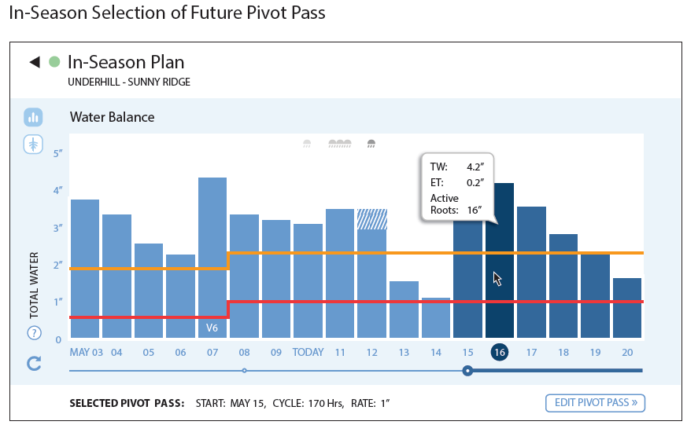

## Test Case: Verify the editing the In-Season Plan functionality is working as expected.

Scenarios will exercise the Selection of Future Pivot Pass functionality and editing the In-Season Plan.

| **Step** | **Perform Action** | **Expected Results** | **P**  **F**  **B** | **Remarks:** Use this section to add comments or notes. Or, actual results if feature was not as expected. You may also reference JIRA bug issue if a defect was written.  **PFB** = (P) assed, (F) ailed or (B) ypassed. The step was bypassed. |
| --- | --- | --- | --- | --- |
|  | **Instructions:**   * See the **Test Environment Supported Devices and Brower** section of this test plan for details. * Enter Browser/Device: | Able to follow instructions. | n/a |  |
|  | **Pre-requisites:**  **Clear** the cache of the browser under test before execution.  **To execute the scenarios** in this test case access to an Operation/Farm must contain at least 1 farm setup with the Water Irrigation Feature.  The following field configuration must also available.   * Fields that have been set up with a probe in the ground. | Test pre-requisites are met.  Familiar with the JIRA story. |  |  |
|  | * Open Jira to GS-713   [https://jira.appliedinvention.com/browse/GS-713](https://jira.appliedinvention.com/browse/GS-709)  Review the specification stated in this:  [Google Doc Water Balance Requirements](https://docs.google.com/a/dannenfeldt.com/document/d/1QPfHrAmKb_Kp-8M99dHP9vtcNt9UTbxbRU6xJA2cLHg/edit) | Able to do as instructed. |  |  |
|  | ***Note to Tester:*** Refer to the Wire Frames.  Observe and confirm any differences with JIRA/Owner expectations. | The latest wireframes will be referenced as instructed.  Able to continue testing. |  |  |
|  | **After** Successfully logging in.  **From** the Water page. Select a field for testing | * Able to do as instructed. * Selected a Field that has been setup that has a probe in the ground i.e. probe data coming in. |  |  |
|  | **Now Click or Tap** on the Plan button. | * The **In-Season** **Plan Page** opens. * The Water Balance Chart is displayed. |  |  |
|  | **Confirm** future Pivot Pass can be edited:   * Select a pivot pass that is in the future | * The Page updates as expected – the footer, chart, overlays etc. * The selected Pivot Pass timeline is darken and its line appears thicken. * The **Edit Pivot Pass** button appears: the button is designed as expected. |  |  |
|  | **Click or Tap on** the **Edit Pivot Pass** button | * The X-axis shorten horizontally displaying only the current day and the 10 day forecast. * The calendar dates and pivot pass line adjust accordingly * The Edit Future Pivot Plan panel opens to the right. |  |  |
|  | **Verify** the Chart buttons in Edit mode | * The **Cancel Edit button** is available * The **Compare Button** is available. |  |  |
|  | **Confirm** the Field Level Settings button is hidden while in edit or comparison mode. | * The **Settings Gear Icon** button is not available. |  |  |
|  | **Confirm** the Soil Depth Icon is hidden while in edit or comparison mode. | * The **Soil Depth Icon** button is not available. |  |  |
|  | **Confirm** the Edit Future Pivot panel is designed and defaults as expected.  ***Note to Tester:*** *review the settings from the Setup Step 2 panel.* | * The **Panel label** is available and position correctly. Its text is correct. * **Pivot Pass Start Date** control is available and defaults to the selected date of the Pivot Cycle. The Pivot Pass Rate displays * **Pivot Pass Cycle** input box is available; its value defaults to the selected Pivot Pass value. There is a radio button next to it and it is checked by default. * The **Pivot Pass Rate** radio is available displaying the selected rate. |  |  |
|  | **Confirm** editing the Pivot Pass Cycle value works as expected.   * Test to try:   + Enter the min values   + Enter the max values   + Enter invalid values. | * The input is accepted if it is a valid value else an error alert is issued. |  |  |
|  | **Confirm** editing the Pivot Pass Rate value works as expected.  -As you perform the test in the step above confirm the Expected Results column accordingly. | * The value shown is as expected which is derived from the Pivot Pass Cycle value. * The value is formatted correctly and as expected. * As the Pivot Pass Cycle value is updated it updates accordingly and is correct |  |  |
|  | **Pausing the pivot.**  Since a pivot date that is in the future was selected in the previous step.   * **Confirm** creating an Irrigation pause works as expected: | * A break is shown in the pivot timeline.   Any irrigation that occurs beyond the end of that Plan will be truncated.  ***Note to Tester: consult the wireframe.*** |  |  |
|  | * **Click or Tap** the **Cancel**  **Edit** button | Any edits made are cancelled and not seen in the Chart. |  |  |
|  | * **Verify** if a new month occurs within the 18-day range, the new month’s abbreviation appear underneath the bar for the first of the month**.** | Able to setup a case to test this. |  |  |
|  | * **Confirm** a maturity marker will appear at the base of a bar when the maturity stage changes. | Able to setup a case to test this. |  |  |
|  | **ad – hoc** **test:**   * Test the surrounding areas of this function: * **Selection Highlighting** refer to the wireframe for scenarios. | Able to do as instructed. |  |  |
| ***Testing is completed for this section***  **Record** Time it took to execute this test:____________________________  (This includes time it took for test setup. It does not include down time i.e. pauses in execution related to taking a break, attend a meeting, etc.) | | | | |

### Test Case: Verify the editing the In-Season Plan with Apply Cycle/Rate Toggle and Comparison functionality is working as expected.

Scenarios will exercise the editing and Comparison the In-Season Plan functionality.

| **Step** | **Perform Action** | **Expected Results** | **P**  **F**  **B** | **Remarks:** Use this section to add comments or notes. Or, actual results if feature was not as expected. You may also reference JIRA bug issue if a defect was written.  **PFB** = (P) assed, (F) ailed or (B) ypassed. The step was bypassed. |
| --- | --- | --- | --- | --- |
|  | **Instructions:**   * See the **Test Environment Supported Devices and Brower** section of this test plan for details. * Enter Browser/Device: | Able to follow instructions. | n/a |  |
|  | **Pre-requisites:**  **Clear** the cache of the browser under test before execution.  **To execute the scenarios** in this test case access to an Operation/Farm must contain at least 1 farm setup with the Water Irrigation Feature.  The following field configuration must also available.   * Fields that have been set up with a probe in the ground. | Test pre-requisites are met.  Familiar with the JIRA story. |  |  |
|  | * Open Jira to GS-713   [https://jira.appliedinvention.com/browse/GS-713](https://jira.appliedinvention.com/browse/GS-709)  Review the specification stated in this:  [Google Doc Water Balance Requirements](https://docs.google.com/a/dannenfeldt.com/document/d/1QPfHrAmKb_Kp-8M99dHP9vtcNt9UTbxbRU6xJA2cLHg/edit) | Able to do as instructed. |  |  |
|  | ***Note to Tester:*** Refer to the Wire Frames.  Observe and confirm any differences with JIRA/Owner expectations. | The latest wireframes will be referenced as instructed.  Able to continue testing. |  |  |
|  | **After** Successfully logging in.  **From** the Water page. Select a field for testing | * Able to do as instructed. * Selected a Field that has been setup that has a probe in the ground i.e. probe data coming in. |  |  |
|  | **Now Click or Tap** on the Plan button. | * The **In-Season** **Plan Page** opens. * The Water Balance Chart is displayed. |  |  |
|  | * Select a pivot pass that is in the future   **Click or Tap on** the **Edit Pivot Pass** button | * The **Edit Pivot Pass** button appears: the button is designed as expected. |  |  |
|  | * Change the Pivot Pass Rate value | * The edit is accepted. The Apply Cycle/Rate line do not appear |  |  |
|  | * Cancel the Edit. | * The Pivot Pass Rate value is not edited. |  |  |
|  | * Change the Pivot Pass Cycle value only | * The edit is accepted. The Apply Cycle/Rate line do not appear |  |  |
|  | * Now, make edits for both the Pivot Pass Rate and Cycle values | * The Apply Cycle/Rate to appear. |  |  |
|  | Click the “**This**” Pass option | * The pivot pass timeline updates as expected. |  |  |
|  | Click the “**Every**” Pass option | * The pivot pass timeline updates as expected. |  |  |
|  | * **Click or Tap** the **Compare Plan** button | * The In-Season redraws displaying both plans: * In top area of the plan is:   + **New Plan** with a Green Icon   + **Current Plan** with a Blue icon   + There is an **Email** icon displayed   + The **Water,Soil depth,Settings** icon are not available.   + The **Question mark and Update** objects are still available.   + There is Pivot Pass Time Line Green and Blue representing each plan. |  |  |
|  | * **Verify** you can go back to the edit * **Click or Tap** the Back to Edit button | Able to return to the edit.  The page appears as expected. |  |  |
|  | * **Click or Tap** on the Compare Plan button. * **Now, Save** the Plan.   **Click or Tap** on the **Save New Plan button** | Able to do as instructed.  The Plan is saved. |  |  |
|  | * **Confirm** a maturity marker will appear at the base of a bar when the maturity stage changes. | Able to setup a case to test this. |  |  |
|  | **ad – hoc** **test:**   * Test the surrounding areas of this function: * **Selection Highlighting** refer to the wireframe for scenarios. | Able to do as instructed. |  |  |
| ***Testing is completed for this section***  **Record** Time it took to execute this test:____________________________  (This includes time it took for test setup. It does not include down time i.e. pauses in execution related to taking a break, attend a meeting, etc.) | | | | |